Hopkins Public Schools has authorized the sale of one School Bus. Sealed Bids for this bus will be accepted until 1:00 PM on Friday, May 18th, 2018, at which time they will be opened, and reviewed.

Please mail bids to Transportation Supervisor Jennifer Frank, 400 Clark St. Hopkins, MI 49328.
To ensure that all bids are sealed until Friday May 18th, please write “SEALED BUS BID” on the outer envelope.

To view this bus, please contact Jennifer Frank at the Hopkins Public Schools Transportation Department at 2747 22nd Street Hopkins, MI or call 269-793-7121. Successful bidders will be contacted by phone.

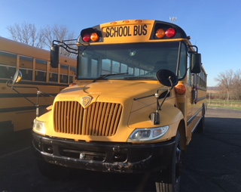
The bus available for sale as is:

Bus #10
2005 International CE300
72-Passenger
International Diesel DT466
210 HP
Air Brakes
Allison 2500
Approximate Miles: 133,024

